# FINAL EXAM

1. The most disadvantaged consumer are the F and G consumers

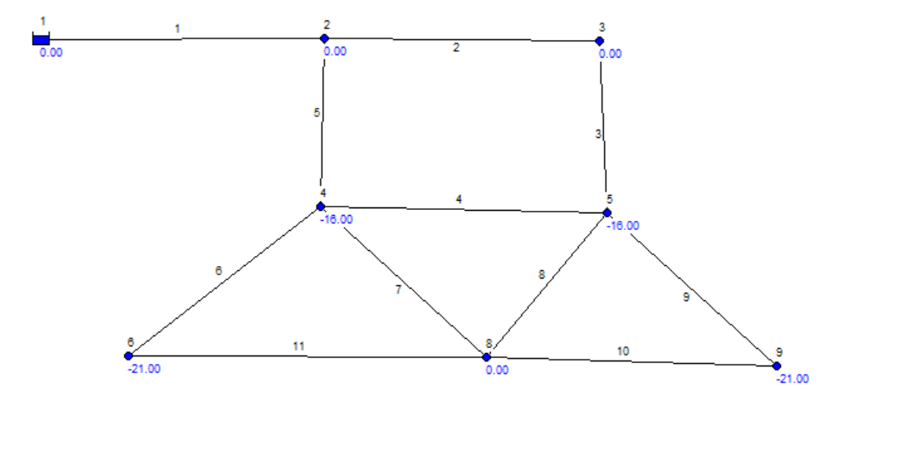

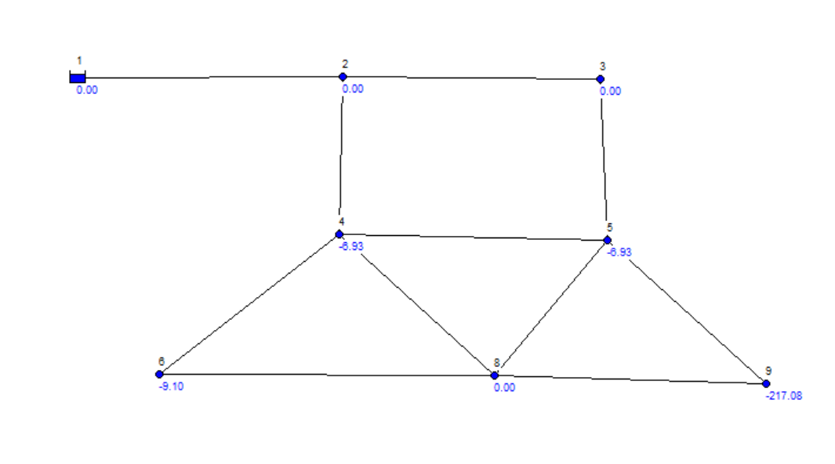

1. Gráfico, Gráfico de líneas

   Descripción generada automáticamenteTotal head for average flow regime is 21.0.
2. Gráfico

   Descripción generada automáticamenteTotal head for the maximus flow regime is 42.89
3. –
4. Gráfico

   Descripción generada automáticamenteTotal heads after establishing commercial consumer are 44.08
5. ---